1)

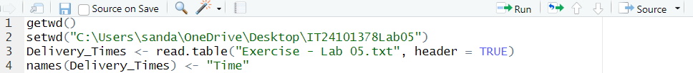

2)

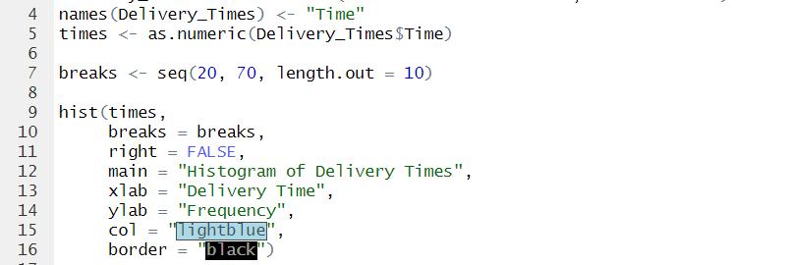

3) The distribution of delivery times is **approximately symmetric, close to bell-shaped**, but with a **slight right skew** due to a few larger delivery times

4)

